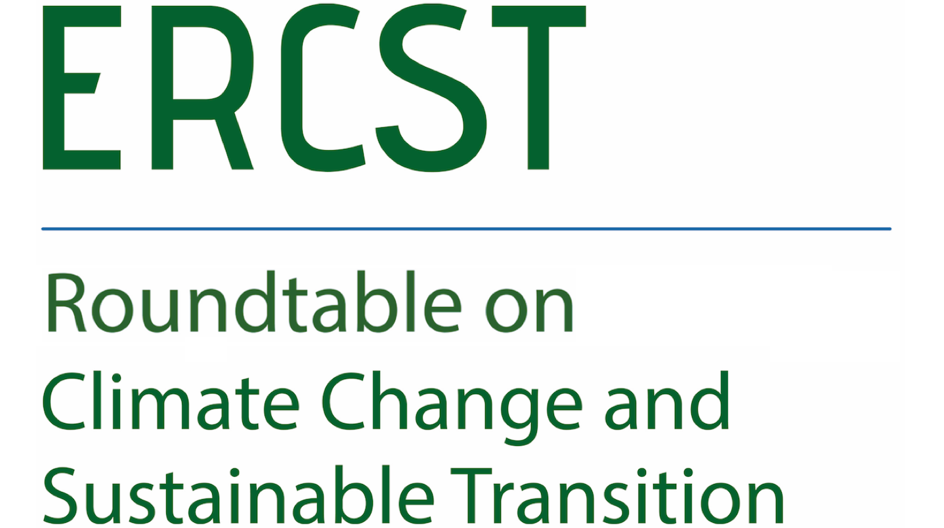

Certification of hydrogen and hydrogen-based products
This meeting is under Chatham House rule
*** Agenda ***

Date: 12.12.2022
Time: 10.00 -12.00 a.m. CET
Location: Hybrid meeting, online and in person (Rue Archimède 61, 1000 Brussels, Belgium)

Most of the different building blocks of the EU hydrogen regulatory framework were already presented in various parts of the Fit for 55 package and the hydrogen and decarbonized gas market package. However, there is one important element which has not been fully addressed in the proposals and is essential for the ramp-up of the hydrogen market, namely the certification of hydrogen and hydrogen-based products.
The market for green products is ready for a rapid development. To meet the targets in the regulation and satisfy the demand, both consumers and producers will need reliable and transparent solutions to certify the renewable or low-carbon attributes of hydrogen and hydrogen-based products, (i.a. green ammonia, green fertilizers or in the future, green steel).
The RED, and the Hydrogen and Gas Directive proposal include incomplete definitions for renewable (RFNBOs) and low-carbon hydrogen. Despite including the emission reduction threshold of 70%, methodologies to assess the GHG emission/carbon footprint reductions for renewable and low-carbon hydrogen have not been adopted yet.
While certification will provide the method to assess the different attributes of hydrogen and will determine compliance towards the targets in the legislation, definitions will provide some of the key building blocks for this method.
On November 9th the Commission is expected to publish a communication on fertilizers which may include some indications as to how hydrogen-based end products will be certified.
This meeting intends to focus on the following issues:
> Why is certification of hydrogen and hydrogen-based products important, and what is the relation between the different methodologies and standards that are emerging?
> What are the interlinkages between the certification of hydrogen and the certification of hydrogen-based end products?
> What are the connection points between a potential EU hydrogen certification scheme and the international standards, and how this is going to affect cross-border flows of hydrogen?

10:00 Welcome and introduction
- A. Marcu, Executive Director of ERCST

10:05 ERCST’s scene setting
- A. Fernandez, ERCST
10:15 Panel discussion
This meeting will start by a presentation by ERCST which will provide the background for the discussion and will introduce the questions for debate. This will be followed by a panel discussion where speakers will have up to ten minutes to provide their views, trying to focus as much as possible on the questions below. Before wrapping up the session there will be a Q&A with interventions from the audience. Questions for discussion:

    - Why is certification of hydrogen and hydrogen-based products important?
    - What is the relation between the different methodologies and standards that are emerging?
    - What are the connection points between the certification of hydrogen and the certification of hydrogen-based end products?
    - What are the connection points between a potential EU hydrogen certification scheme and the international standards, and how this is going to affect cross-border flows of hydrogen?

Moderator: O. Imbault, ERCST

- R. Macrae, Fortescue Future Industries
- K. Dayly, Energytag
- D. Nochevnik, Hydrogen Council
- S. Bartlett, Green Hydrogen Organization
- N. Romanowski, CEFIC

11:30 First round of discussions and Q&A

11:50 Final remarks and end of the meeting

