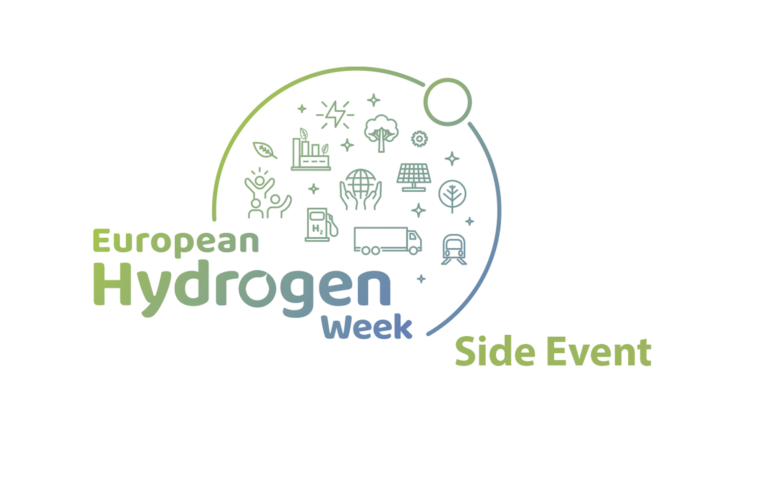
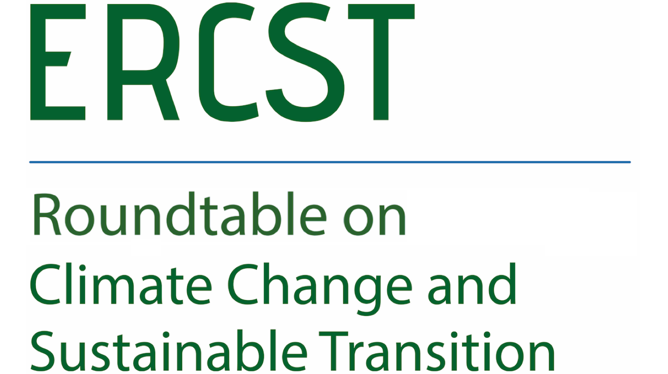

This event has been selected as a side event within the European Hydrogen Week 2022
The principle of technological neutrality and hydrogen incentives
*** Agenda ***

Date: 27.10.2022
Time: 10.00 a.m. -12.00 p.m. CET
Location: Hybrid meeting, online and in person (ERCST’s offices, Rue Archimède 61, 1000 Brussels)

While the focus of the European Commission Hydrogen Strategy clearly lies on renewable hydrogen, the strategy acknowledges that in the short and medium term, other forms of low-carbon hydrogen are needed to rapidly reduce emissions from existing hydrogen production and support the parallel and future uptake of renewable hydrogen. In a similar approach, the REPowerEU communication mentions that to achieve 10 million tons of EU renewable hydrogen domestic production, other forms of fossil-free hydrogen, notably nuclear-based are needed.
Most of the different building blocks of the hydrogen regulatory framework were already presented in various parts of the Fit for 55 package and the hydrogen and decarbonized gas market package. However, the translation of the policy vision for low-carbon hydrogen portrayed in the strategy and REPowerEU into the proposals is still not complete. As an example, the European Commission has left the key elements of the low-carbon hydrogen definition for secondary legislation (to be proposed by 2024).
This meeting intends to assess two main issues:
Firstly, whether ramp-up of the EU hydrogen economy is possible without the contribution of different forms of decarbonized hydrogen other than RFNBOs.
Secondly, how to align the European Commission’s policy vision (set out in the hydrogen strategy and REPowerEU) regarding the role of low-carbon hydrogen in the transition with a complete regulatory framework.

10:00 Welcome and introduction
- A. Marcu, Executive Director of ERCST
- O. Imbault, Senior Fellow ERCST

10:10 ERCST views and scene setting
- A. Fernandez, ERCST
10:15 Preliminary remarks
- R. Kempener, European Commission
This meeting will start with preliminary remarks by ERCST, outlining some of the key aspects around the technological neutrality principle and hydrogen incentives. This will be followed by a discussion where panelists will have between 5 to 10 min. to address the following questions:

- Is it possible to ramp-up the EU-hydrogen economy without the contribution of low-carbon hydrogen?
- Would a technology neutral approach to incentives based on the carbon footprint of the hydrogen produced favor the ramp-up of the EU hydrogen economy?
- How could the demand side of the hydrogen market be supported in decarbonizing at affordable prices considering the current energy crisis?
This will be followed by a Q&A with questions from the audience.

10:30 Panel discussion

Chair: O. Imbault, ERCST

- M. Labatut, EDF
- L. Haustermans, Yara
- E. Bollendorff, CAN Europe
- S. Pujau, France Hydrogen
- A. Daemers, SolarPower Europe

11:25 First round of discussions and Q&A

11:50 Final remarks and end of the meeting

